GIT

- Git-HOL
Repository setup
mkdir GitDemo
cd GitDemo
git init
echo "Welcome to Git Hands-On Lab" > welcome.txt
git status
git add welcome.txt
git commit
git remote add origin https://github.com/yourusername/GitDemo.git
git push -u origin master

Configure git
git --version
git config --global user.name "Your Name"
git config --global user.email "your.email@example.com"
git config –list

- To check, if notepad++.exe execute from Git bash

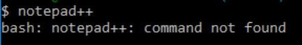
If Git bash could not able to recognize notepad++ command that implies notepad++.exe is note added to the environment path variable.

To add path of notepad++.exe to environment variable, go to control panel -> System -> Advanced System settings. Go to Advanced tab -> Environment variables -> Add path of notepad++.exe to the path user variable by clicking on “Edit”
- Exit Git bash shell, open bash shell and execute

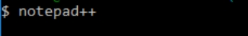

Now, notepad++ will open from Git bash shell

- To create an alias command for notepad++.exe, execute

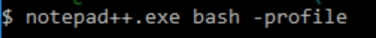

It will open notepad++ from bash shell, and create a user profile by adding the line in notepad++

- To configure the editor, execute the command

- To verify if notepad++ is the default editor, execute the command
Here ‘-e’ option implies editor

It will show the entire global configuration as shown below,
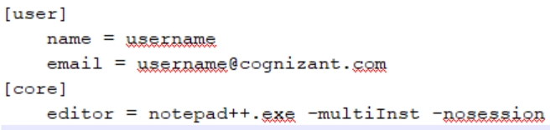

Step 3: Add a file to source code repository

- Open Git bash shell and create a new project “GitDemo” by executing the command

- Git bash initializes the “GitDemo” repository. To verify, execute the command
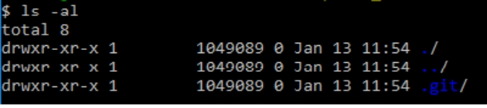
It will display all the hidden files in the Git “working directory”.

- To create a file “welcome.txt” and add content to the file, execute the command

- To verify if the file “welcome.txt” is created, execute
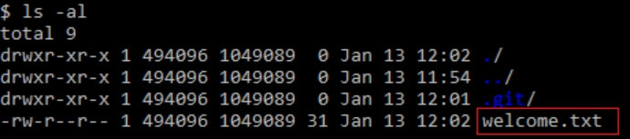

- To verify the content, execute the command

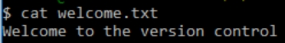

- Check the status by executing
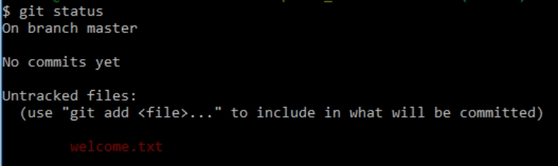

Now the file “welcome.txt” is available in Git “working directory”

- To make the file to be tracked by Git repository, execute the command

- To add multi line comments, we are opening default editor to comment. Execute the command

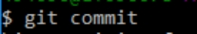
Notepad++ editor will open and to add multi-line comment with default editor

- To check if local and “Working Directory” git repository are same, execute git status

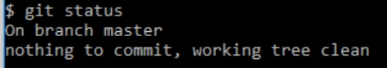

welcome.txt is added to the local repository.

- Signup with GitLab and create a remote repository “GitDemo”
- To pull the remote repository, execute

git pull origin master

- To push the local to remote repository, execute

git push origin master

- Git-HOL

Creating a local github repo
mkdir GitIgnoreDemo
cd GitIgnoreDemo
git init

Create a .gitignore File
touch .gitignore
notepad++ .gitignore
Inside .gitignore, add:
*.log
log/

Create Files or Folders to Ignore
echo "This is a sample log file" > sample.log
mkdir log
echo "Some logs inside log folder" > log/error.log

Check Git Status
Git status

Add Remaining Files and Commit

echo "README for GitIgnoreDemo" > README.md
git add README.md
git commit -m "Added README, ignored .log files and log folder"

- Git-HOL

Prerequisites

Git installed and configured

P4Merge installed and configured:

Download: https://www.perforce.com/products/helix-core-apps/merge-diff-tool-p4merge
mcd
git config --global merge.tool p4merge
git config --global mergetool.p4merge.cmd '"C:/Program Files/Perforce/p4merge.exe" "$BASE" "$LOCAL" "$REMOTE" "$MERGED"'
git config --global diff.tool p4merge
git config --global difftool.p4merge.cmd '"C:/Program Files/Perforce/p4merge.exe" "$LOCAL" "$REMOTE"'

Merge Steps

git checkout master
git diff master GitNewBranch
git difftool master GitNewBranch
git merge GitNewBranch
git log --oneline --graph --decorate
git branch -d GitNewBranch
git status

Makes Changes

"This is from the new branch" > feature.txt
git add feature.txt
git commit -m "Added feature.txt in GitNewBranch"
git status

Branching Instructions
Create and switch
git branch GitNewBranch
git branch -a
git checkout GitNewBranch

- Git-HOL

View History and Differences

git log --oneline --graph --decorate --all
git diff master GitWork
git difftool master GitWork

Use 3-Way Merge Tool (P4Merge)
git mergetool
P4Merge opens with:

BASE (common ancestor)

LOCAL (master)

REMOTE (GitWork)

Prerequisites
Git and Git Bash installed

Notepad++ and P4Merge installed

A clean master branch in your local repository

Merge and Resolve Conflict

git config --global diff.tool p4merge
git config --global difftool.p4merge.cmd '"C:/Program Files/Perforce/p4merge.exe" "$LOCAL" "$REMOTE"'
git merge GitWork
Finalize the Merge
git add hello.xml
git commit -m "Resolved conflict in hello.xml while merging GitWork into master"

Delete Branch and View Final Log
git branch -d GitWork
git log --oneline --graph –decorate

Create GitWork Branch and Add File
git checkout -b GitWork
echo "<message>Hello from GitWork branch</message>" > hello.xml
git status
git add hello.xml
git commit -m "Added hello.xml in GitWork branch"

Create Conflicting File in Master

git checkout master
echo "<message>Hello from master branch</message>" > hello.xml
git add hello.xml
git commit -m "Added hello.xml in master branch with different content"

Cleanup and Ignore Merge Backup Files
echo "*.orig" >> .gitignore
git add .gitignore
git commit -m "Added .orig files to .gitignore"

- Git-HOL
Verify master branch is clean
git checkout master
git status
Push pending local commits to remote

git push origin master

Pull latest changes from remote

git pull origin master

Prerequisites
You have already completed Git-T03-HOL_002 (from previous HOLs)

Remote Git repo is already set up (GitHub/GitLab)

Internet connection is active

You’re on the master branch

List all available branches

git branch -a

